|  |  |
| --- | --- |
| ­­­­­  CLS | sign up  Group Assignment | Abstract COMSATS Literary Society is one of the distinct societies of COMSATS Institute of Information Technology. This is the only society that is improving its quality with the use of I.T. Now, students would be able to register their selves online. Course Java | Object Oriented programming Submitted By **Rimsha Bilal | CIIT/FA17-BS(CS)-062/SWL Alina Raza | CIIT/FA17-BS(CS)-072/SWL Usama Sarwar | CIIT/FA17-BS(CS)-090/SWL** Submitted to Mr. Shehzad Dated April 9, 2018 |



COMSATS Institute of Information Technology  
Sahiwal Campus

Usama Sarwar | CIIT/FA17-BS(CS)-090/SWL

### COMSATS Literary Society | Sign Up

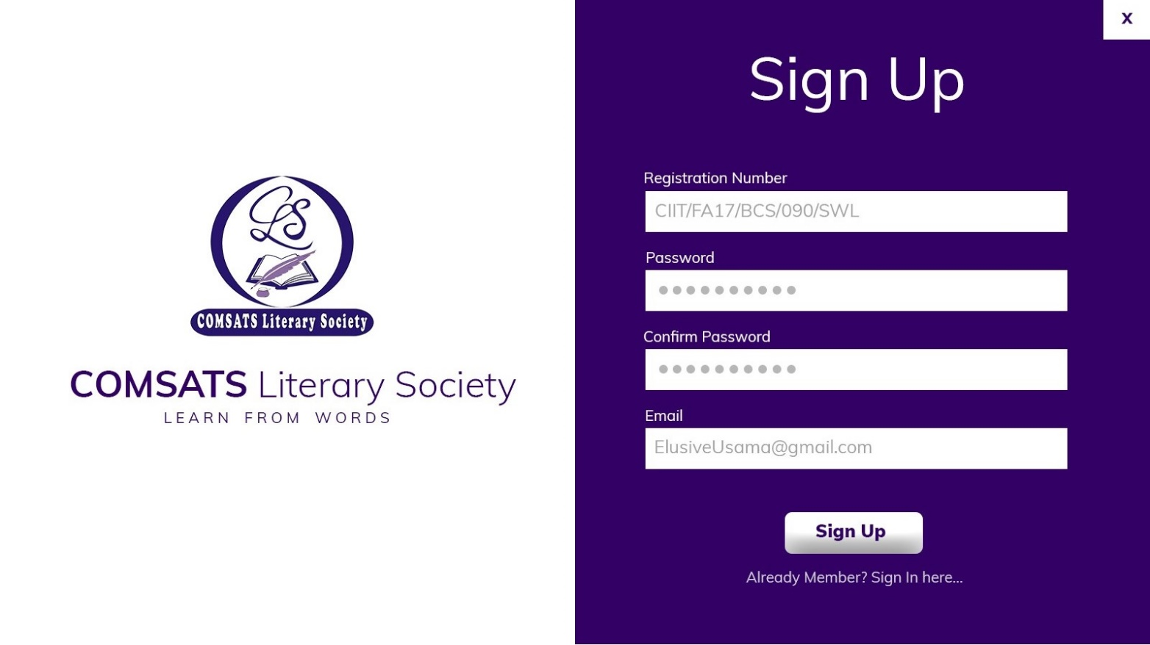

# Purpose

The purpose of this project is to develop an application that would help students to get their-self registered in CLS online. No more wastage of **paper** and **ballpoints**. Any student of CIIT university would be able to sign up via website [www.clssahiwal.cf](http://www.clssahiwal.cf) without wasting his/her **precious time**. After sign up, only those students would be able to see Society activities who would have signed in with their password.

# SCOPE

The online registration system is a portal type that covers the major processes in the enrollment of freshmen, old, transferee and dropout students, files maintenance such as listing of enrolled students in different year levels. Administrators have total access to the system, confirming the students who are currently registering and/or enrolling, generating records, sectioning the students in every year level. The system gives further information about the registration process as to know how many students are registered in every year level.

# Functional Requirements

* A valid Registration number that would only belong to CIIT.
* A strong password.
* An Working and Active Email address.

# Non-Functional requirements

* A computer System
* Working Data Connection (Internet Access)
* Student to be registered